Adafruit M0 Adalogger – Pin Utilization

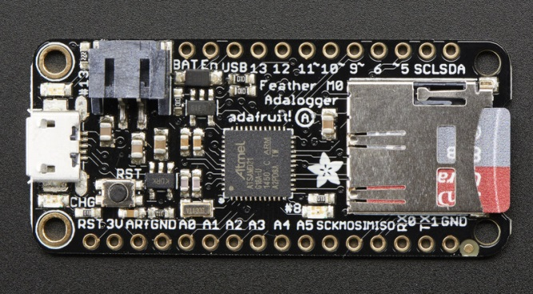 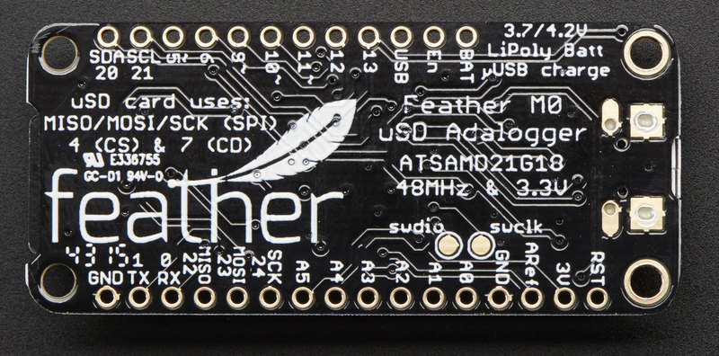

Pin Utilization & Description

| Pin ID | Description | Main  Board | RTC  Module | Ethernet  Module | OLED  Module | Proto  Board |
| --- | --- | --- | --- | --- | --- | --- |
| BAT | + Terminal from Battery Plug | X |  |  |  |  |
| EN | 3.3V Regulator Enable Pin (Pulled up to 3.3V). Ground to disable on-board regulator. | X |  |  |  |  |
| USB | + Voltage to/from Micro-USB plug |  |  |  |  | X |
| 13 | GPIO #13 (also RED LED on base board) | X |  |  |  |  |
| 12 | GPIO #12 |  |  |  |  | X  Pnl LED |
| 11 | GPIO #11 |  |  |  |  | X  Pnl LED |
| 10 | GPIO #10 |  |  | X (CS – SPI) |  |  |
| 9* | GPIO #9 & Analog in A7 connected to divider to measure Lipo battery. (sits around 2VDC due to divider). | X |  |  | X  Button A |  |
| 6 | GPIO #6 |  |  |  | X  Button B | X  Pnl Btn |
| 5 | GPIO #5 |  |  |  | X  Button C | X  Pnl Btn |
| SCL  (21) | I2C Clock Pin (no internal pull-up) |  | X (0x68)  10k PU |  | X (0x38)  2.2k PU |  |
| SDA  (20) | I2C Data Pin (no internal pull-up) |  | X  (0x68)  10k PU |  | X (0X38)  2.2k PU |  |
| RST | Reset Pin. Ground to reset device |  | X | X | X |  |
| 3V | Output from 3.3V regulator 500mA maximum | X | X | X | X |  |
| Aref | Analog Reverence (3.3V Maximum) |  |  |  |  |  |
| GND | System Ground Plane | X | X | X | X | X |
| A0 | True Analog output (DAC) or Analog input |  |  |  |  |  |
| A1 | Analog Input or Digital I/O |  |  |  |  | X (USB V) |
| A2 | Analog Input or Digital I/O |  |  |  |  |  |
| A3 | Analog Input or Digital I/O |  |  |  |  |  |
| A4 | Analog Input or Digital I/O |  |  |  |  |  |
| A5 | Analog Input or Digital I/O |  |  |  |  |  |
| SCK  (24) | SPI bus Clock | X |  | X |  |  |
| MOSI | SPI data bus | X |  | X |  |  |
| MISO | SPI data bus | X |  | X |  |  |
| 0(RX) | Serial Bus Receive – GPIO #0 or Analog In  Serial1 (hardware UART) |  |  |  |  |  |
| 1(TX) | Serial Bus Transmit – GPIO #1 or Analog In |  |  |  |  |  |

* Conflict at GPIO #9. Button A cannot be used on OLED display.

Internal Adalogger M0 Pin Utilization & Description (not brought out to headers)

| Pin ID | Description | Main  Board | RTC  Module | Ethernet  Module | OLED  Module |
| --- | --- | --- | --- | --- | --- |
| 4 | GPIO #4 – Used for Chip Select on SD Card SPI Bus | X (CS) |  |  |  |
| 7 | GPIO #7 - Used as Card detect for SD Card. Input is pulled low when card is removed. | X |  |  |  |
| 8 | GPIO #8 – Wired to greed LED on base board | X |  |  |  |

Power Consumption

Adafruit Adalogger M0 regulator maximum output +500.0 mA

* RTC Board (Onboard CR1220 12mm Coin Cell ~5yr lifespan) -000.2 mA
* OLED Board (maximum current draw) -010.0 mA
* Ethernet Module (maximum during transmit) -150.0 mA

Regulator balance (overhead) 339.8 mA

Battery Charger

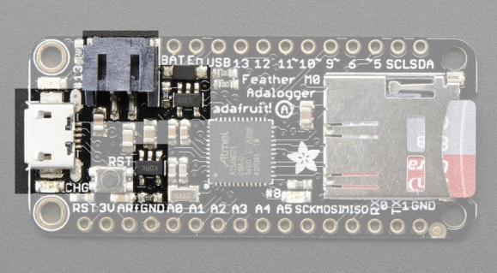

Onboard battery Lipoly Battery charger will supply 100mA to battery when 5V USB plug is connected. Fully charged battery will measure around 4.2V and the will drop to around 3.7V for majority of its run cycle. Battery voltage will drop to around 3.2V when it is about to flat-line.